v. 1.0.2

Member App

User Guide

Member App

User Guide

v. 1.0.2



https://apps.apple.com/us/app/aliviride/id1458751168

https://play.google.com/store/apps/details?id=com.alivi.memberapp&pcampaignid=web_share

Y0020_WCM_143656E_C Internal Approved 01192024 FL4WCMGDE43656E_0124

© Wellcare 2024

**Register**

To use the AliviRide app, you must first download and then create a NEW USER in three steps:

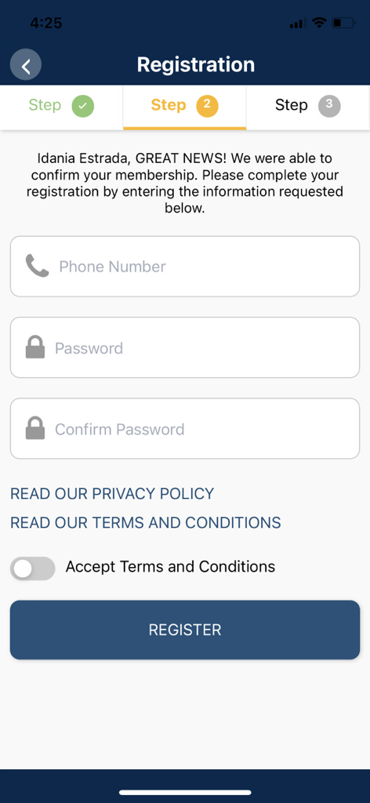



Step 2: You must set up your

account using your phone number and password. You must also accept the terms and conditions.

Step 1: You must enter your

first and last name, member ID and date of birth, then tap the "Verify" button.





**Register**

Step 3: You must verify the mobile number by inputting a code that is sent via text message to your phone number provided in step 2.

If successful, a screen displays

showing Verification Complete.

You can now sign in and start

booking trips.



**Sign In**

You can sign in with your phone number and password. There is an option to "remember phone number" for future sign in.

Once the **SIGN IN**

button is pressed, the App will open the **HOME** page, displaying your remaining

trip balance and information on upcoming trips.



‘’’’’





**Create a Trip**

You can schedule a new trip on the home screen by tapping the yellow button that says, "CREATE A NEW TRIP."

Step 1: You must select a level

of service from the available options.



**Create a Trip**

Step 2: Select when you want the ride, either now or scheduled for a later date. (The "Pick Up Now" option directs you to rideshare.)

When completed, press **BOOK** to

save the trip.



**Create a Trip**

To select a Pickup & Drop Off

Address, you will be shown your Previous Locations saved (if available) or you can add a new one.

To SAVE a new address, the

following is needed: Location Type, Name, Address

and Phone.

After completing the needed

fields, tap BOOK to save.



**Create a Trip**

The AliviRide App will look for

a driver to send right away if using **Rideshare** with **Pickup Now.**

If the trip is scheduled for the

future, you will only see a notification at the bottom showing the trip was created.

On the **home** screen, you will

see all scheduled trips, including now and future dates.

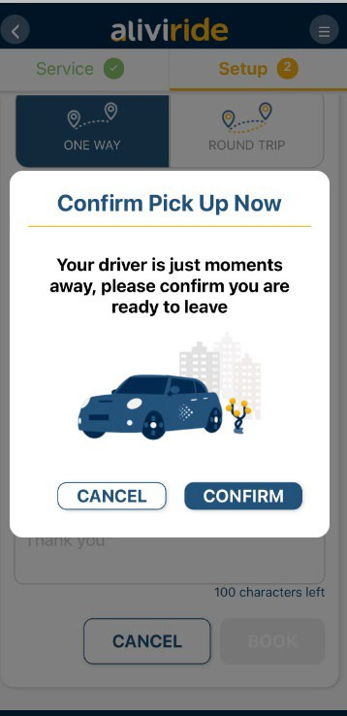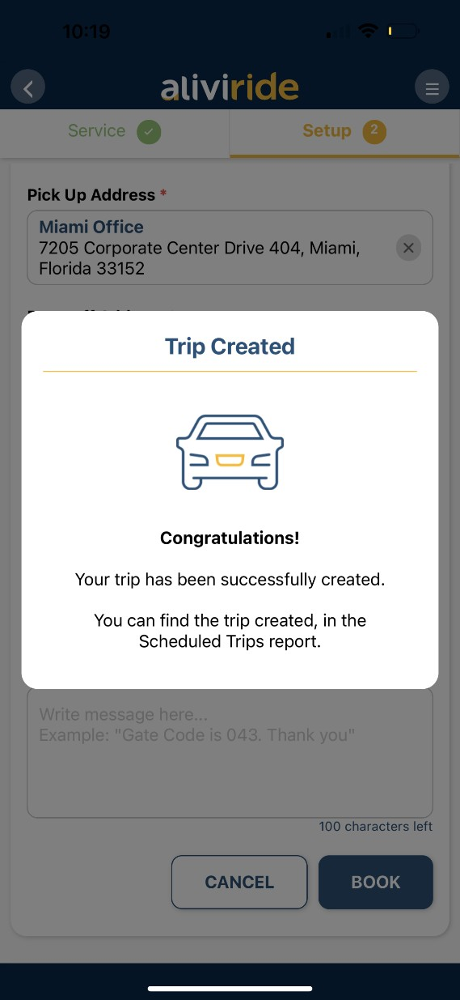

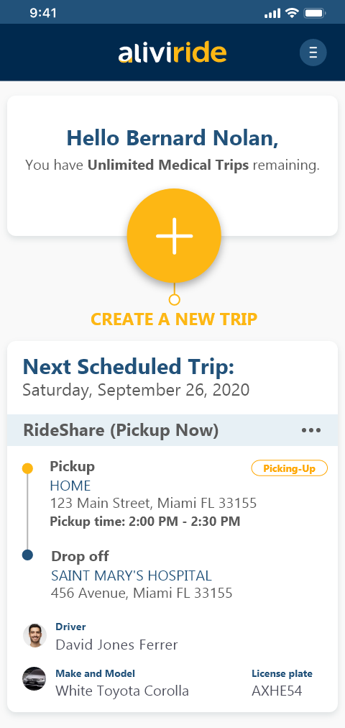

**Menu**

From the top right **Menu,** you can navigate to all options in the App.

Within the Menu screen, you will

find your name, health plan, trip options, links to the terms and conditions, option to call support and language selection.

Additionally, at the bottom of the

screen, you can find the App version and the option to "Log Out" of the App.

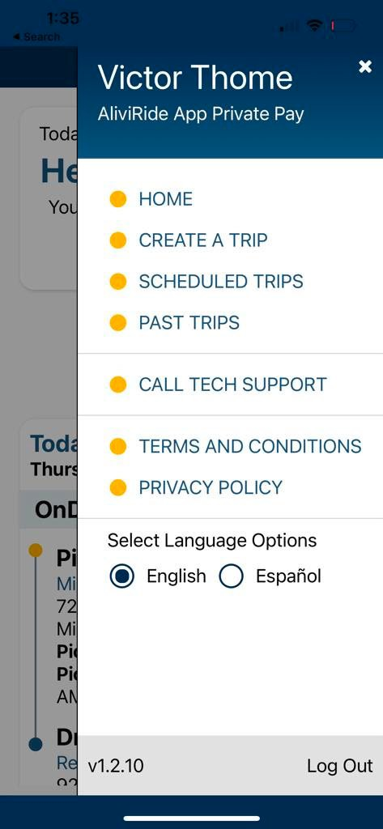



**Scheduled**

**& Past Trips**

You can see your **Scheduled** or

**Past Trips** via the top right **Menu**.

In these screens you can see the

details and status of

any **Scheduled** or **Past Trips.**

v



**Rate a Trip**

At the end of each trip, a new window will appear so you may evaluate your trip experience. You can also provide a rating to past trips via the **Past Trips screen**.

Finally, you can choose to

"CANCEL" or "SAVE" your trip rating.

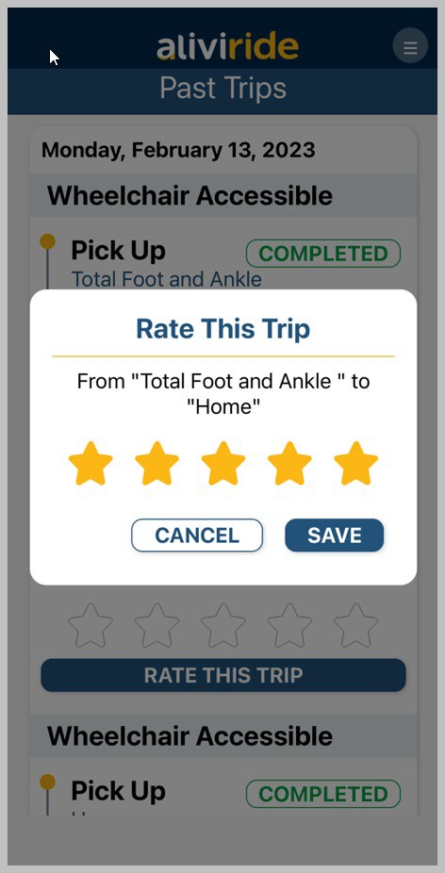

Terms and Conditions

AliviRide mobile application terms and conditions and privacy policy can be found at:

[www.alivi.com/legal](http://www.alivi.com/legal)